**LINUX PROGRAMMING**

PRACTICE QUESTIONS

**NAME: VIGNESHWARAN.P**

**REGNO: 16MIS1143**

**1. Script 1**

sudo apt-get install sl

sl

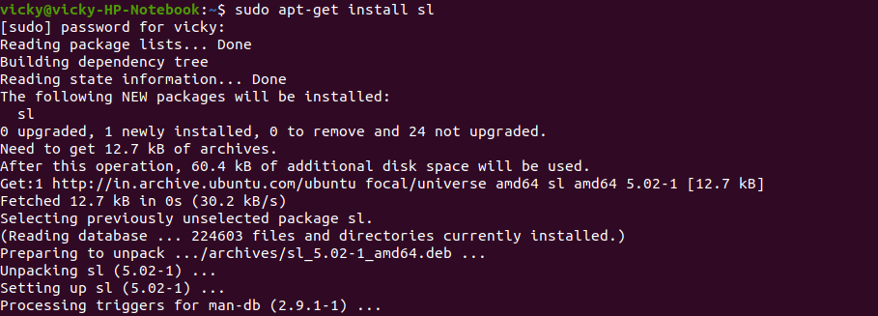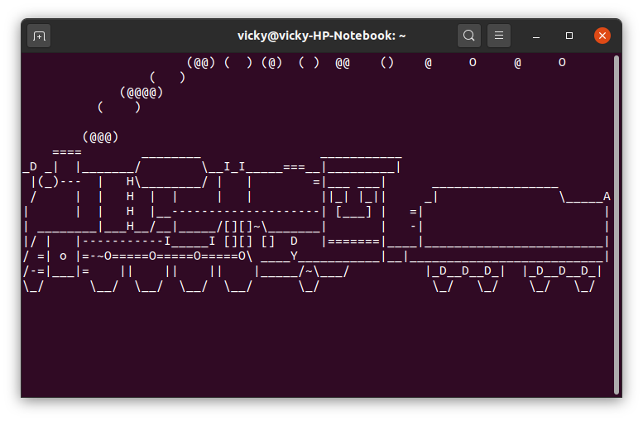

**2. Script 2**

rev

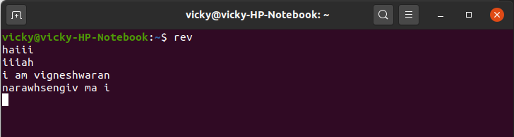

factor

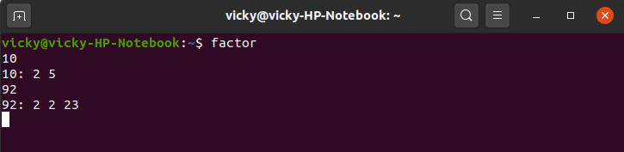

yes

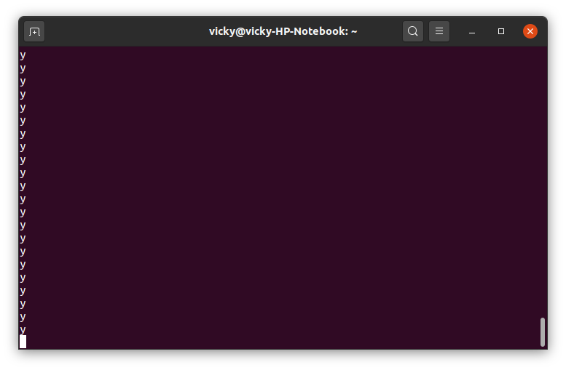

**ADDITIONAL QUESTION:**

**Write a C program to implement Simple reader-writer algorithm using a shared memory segment with semaphore**

**Server:**

#include<stdio.h>

#include<stdlib.h>

#include<string.h>

#include<sys/types.h>

#include<sys/ipc.h>

#include<sys/shm.h>

#define SHSIZE 100

int main(int argc,char *argv[])

{

int shmid;

key_t key;

char *shm;

char *s;

//Let key=some ram=ndom integer

key=9876;

shmid=shmget(key,SHSIZE,IPC_CREAT | 0666);

if(shmid<0)

{

perror("Shmget");

exit(1);

}

shm=shmat(shmid,NULL,0);

if(shm==(char *)-1)

{

perror("shmat");

exit(1);

}

memcpy(shm,"Vigneshwaran",12);

s=shm;

s+=12;

*s=0;

while(*shm!='*')

{

sleep(1);

}

}

**Client:**

#include<stdio.h>

#include<stdlib.h>

#include<string.h>

#include<sys/types.h>

#include<sys/ipc.h>

#include<sys/shm.h>

#define SHSIZE 100

int main(int argc,char *argv[])

{

int shmid;

key_t key;

char *shm;

char *s;

//Let key=some ram=ndom integer

key=9876;

shmid=shmget(key,SHSIZE,0666);

if(shmid<0)

{

perror("Shmget");

exit(1);

}

shm=shmat(shmid,NULL,0);

if(shm==(char *)-1)

{

perror("shmat");

exit(1);

}

for(s=shm;*s!=0;s++)

{

printf("%c",*s);

}

printf("\n");

*shm='*';

}

**Output:**

**Server:**



**Client:**



**HOT QUESTION:**

**Write a bash shell script to monitor the health of your system. Let the details be stored and archived in any folder of your choice.**

**CODE:**

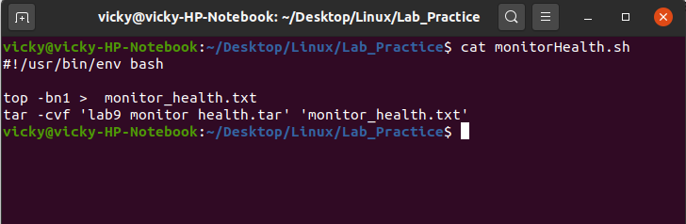

crontab -e

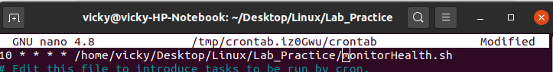

**NOTE: This will execute for every 10 minutes.**

**After executing,**